Date: 23.04.2024

**Work Done Certificate**

This is to certify that **M/s. Nortcele Systems Private Limited; Bangalore** has developed following modules related to S3 Web App.

1. Visitor Management
2. Service Request / Helpdesk
3. Purchase /Procurement
4. Material Management / Stores / Asset Management.
5. HRMS / Personnel
6. Accounts / Finance

Still the next phase of feature development is continuing from M/s. Nortcele Systems Private Limited.

Nortcele Systems performance was always satisfactory and the support from them was always excellent.

We wish them all the best for future endeavors.

Best Regards,

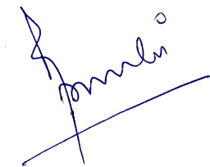

**Azeagaia Development Pvt Ltd**